Exercise Solution

Task – 01
Write a simple x86 assembly program that performs a logical NOT operation on
the value 0xAA (hexadecimal for 170). Use the NOT instruction to invert the bits
and display the result in hexadecimal format.

INPUT:
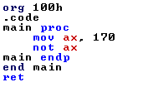

OUTPUT:
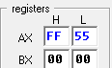

Task – 02
Create an x86 assembly program that initializes two values, 0xCC (hexadecimal
for 204) and 0x33 (hexadecimal for 51). Perform a bitwise AND operation on
these values using the AND instruction and print the resulting value after the
operation.

INPUT:
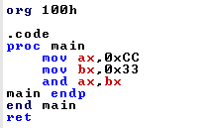

OUTPUT:

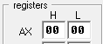

Task-03
Write an x86 assembly program that combines the values 0xF0 (hexadecimal for
240) and 0x0F (hexadecimal for 15) using the logical OR instruction. Output the
result in hexadecimal format.

INPUT:
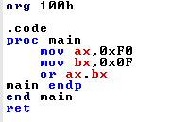
OUTPUT:
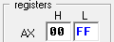

:
Task – 04
Develop an x86 assembly program that performs a bitwise XOR operation between the values 0xCC (hexadecimal for 204) and 0x33 (hexadecimal for 51) using the XOR instruction. Display the result after performing the operation.

INPUT:
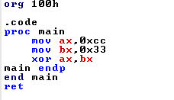

OUTPUT:
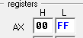

Task – 05
Create a program that checks whether the number 0x05 (hexadecimal for 5) is odd
or even using a logical operation. Perform an AND operation with 0x01 to
determine the result. Print "Odd" if the result is 1, and "Even" if the result is 0.

INPUT:
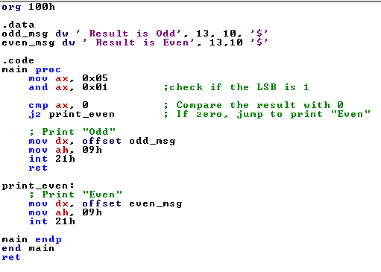

OUTPUT:
